THE WAY OF THE CROSS

by Donal Neary SJ

**Introduction** (in the Lady Chapel)

Priest: We meet in the name of the Father and of the Son and of the Holy Spirit. **Amen**

When we walk the Way of the Cross, we are invited to walk side by side with our Lord. As disciples, our lives should mirror that of Jesus – lives filled with the whole range of human emotions – trying to be more like the Father. Walking the Way of the Cross, we learn from our Lord’s response to the people he met on that journey, and find our lives illuminated by his goodness and love. By following the way of the cross, we are challenged and empowered to bring Christ into our world.

[Pause]

Let us pray:

Almighty and everlasting God, who in your tender love towards the human race sent your Son our Saviour Jesus Christ to take upon him our flesh and to suffer death upon the cross: grant that we may follow the example of his patience and humility, and also be made partakers of his resurrection; through Jesus Christ your Son our Lord, who is alive and reigns with you in the unity of the Holy Spirit, one God, now and for ever. **Amen.**

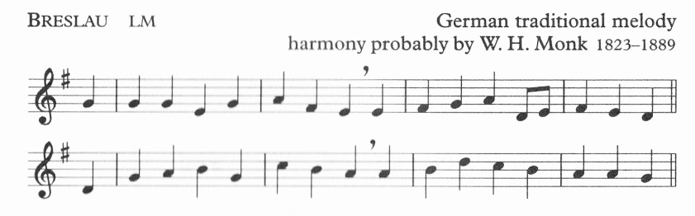

Take up thy cross, the Saviour said,

if thou wouldst my disciple be;

deny thyself, the world forsake,

and humbly follow after me.

Take up thy cross then in his strength,

and calmly every danger brave;

’twill guide thee to a better home,

and lead to victory o’er the grave.

First Station

## JESUS IS CONDEMNED TO DEATH

Leader: We adore you, O Christ, and we bless you

**All: For by your cross, you have redeemed and saved us.**

Voice 1 People gather to watch,

taking part in injustice and hatred

without even knowing it.

So often that can happen.

Our taxes may go to purchase arms which will kill the poor;

our words add to gossip destructive of the good name of another.

Unknown to ourselves

we may pour the water of condemnation.

Pilate is caught between guarding his job and prestige,

and doing what is right and just.

Don't we all know it's difficult to do the right thing

when others are pressurising us to do

what is less good, what is wrong?

I wonder did those who stood and watched that night

see in Jesus' eyes his conviction and love?

Love was stronger than the fear of what was to come.

Had Jesus not wondered and feared

that it would come to something like this;

and as he left Pilate,

did he know it would get worse?

And did he have the faith

that the condemnation to death

would lead him to the gift of new life?

**Prayers**

Voice 2 *We adore you, Christ our Lord and Saviour,*

*we praise your name in suffering and death;*

*Lord in your mercy,*

All: hear our prayer.

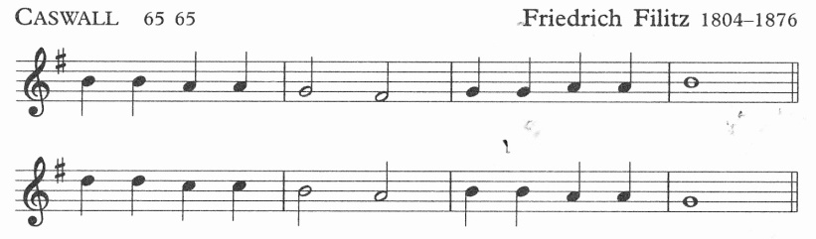

Glory be to Jesus,

who, in bitter pains,

poured for me the life-blood

from his sacred veins.

Second Station

## JESUS TAKES UP HIS CROSS

Leader: We adore you, O Christ, and we bless you

**All: For by your cross, you have redeemed and saved us.**

Voice 1 A lone moment while we focus just on Jesus.

He is not given the cross, nor loaded with it.

Placed on the back that never asked for it,

the body already broken and bruised,

Jesus was actively accepting his cross.

Don't we know people who have done this?

Who have accepted fully the cross of life,

or who have allowed themselves suffer for others.

It's a lonely moment to accept a cross:

when you know that you are terminally ill,

when you know a loved one has truly left you,

when you know the loss of bereavement, failure, rejection,

when you allow yourself enter loneliness and pain,

when you suffer through any mistake you made in life.

And the difference is

that none of us need take our cross alone.

God carries our cross with us,

as he carried it with his Son.

Others help us too,

the people who care for us in our lives,

who help us take up our crosses.

They are the care and love of Jesus for us.

## Prayers

### Voice 2 Lord teach me to know you more, love you more

*and serve you more faithfully in my life.*

*Lord in your mercy,*

All: hear our prayer.

Grace and life eternal

in that blood I find;

blest be his compassion

infinitely kind.

Third Station

## JESUS FALLS FOR THE FIRST TIME

Leader: We adore you, O Christ, and we bless you

**All: For by your cross, you have redeemed and saved us.**

Voice 1 Did any of them help the man on the ground?

Or did they just watch?

Observing, judging, afraid of another’s fall;

only one face looks at him.

That's the way often;

people fall in different ways and we watch,

love gone wrong, exploitation in work,

or people forced out of home or country.

Or sin we hoped we could get over,

faults and failings which are always part of life.

He seems to be getting up from his fall,

his hand supporting him, and the face a bit crushed.

Maybe he knows that there's no help around him

and he must go it alone for another while.

Have you ever needed a hand,

like he needed a hand,

and all they did was watched?

Or talked about your pain from a distance?

He knows what it was like for you,

and then you know there is a hand always there,

the hand of God wounded but comforting.

## Prayers

*Voice 2 Lead us not into temptation,*

*and when we find ourselves fallen,*

*raise us up on the path of life.*

*Lord in your mercy,*

All: hear our prayer.

Blest through endless ages

be the precious stream,

which from endless torments

did the world redeem.

Fourth Station

## JESUS MEETS HIS MOTHER

Leader: We adore you, O Christ, and we bless you

**All: For by your cross, you have redeemed and saved us.**

Voice 1 He didn't really 'meet' her - she was there;

and not by chance.

She wanted to be with her Son

even though it would be the cruellest moment of her life.

She didn't have to be there;

just like a parent doesn't have to be in the hospital all night with a child;

just like the child doesn't have to be with the parent who is ill;

just like the sister doesn't have to visit the brother in prison.

We visit in times of trouble from love:

visits of love, stations of love.

He didn't have to stop either;

it would be enough just to go on,

just to think of himself and get this over and done with.

Knowing his mother was suffering so much —

this was one of the cruellest moments so far.

He didn't have to stop,

just like the man on the way home to the comfort of family

doesn't have to stop and help on the soup-run,

or the student on the way to a first-class degree

didn't have to stop and help the weaker one.

They both suffered so much,

she for him, and he for us.

So far, and there was more to come.

## Prayers

*Voice 2 Be with us Lord when we are in trouble,*

*be with us as you were with Mary in her trouble.*

*Lord in your mercy,*

All: hear our prayer.

Abel’s blood for vengeance

pleaded to the skies;

but the blood of Jesus

for our pardon cries

Fifth Station

## SIMON OF CYRENE HELPS JESUS TO CARRY HIS CROSS

Leader: We adore you, O Christ, and we bless you

**All: For by your cross, you have redeemed and saved us.**

Voice 1 He seems to be telling Jesus to let go the cross

and he would carry it for him.

Simon — a person who wants to help,

to ease the burden, carry the load,

his sons knew Jesus, so he had probably met him.

Many are like that,

people giving a helping hand in financial trouble,

donating an organ of the body for another's health,

men and women carrying the cross for each other.

Simon seems to be willing to do this.

The others watch,

and maybe one of them takes a step forward to help.

Suffering brings out compassion in us.

And Jesus?

Glad to be helped, comforted,

to know that his suffering was understood,

even without many words

but with a healing touch and a prayer,

and that in the crowd there was companionship,

as we know another's help in our

bereavement, illness, rejection, let-down.

Glad to know that somebody wanted to help.

**Prayers**

*Voice 2 Open our arms Lord to help with the crosses of others,*

*and then we know we are helping carry your cross.*

*Lord in your mercy,*

All: hear our prayer.

Oft as it is sprinkled

on our guilty hearts,

Satan in confusion

terror-struck departs.

Sixth Station

## VERONICA WIPES THE FACE OF JESUS

Leader: We adore you, O Christ, and we bless you

**All: For by your cross, you have redeemed and saved us.**

Voice 1 He needed help.

The way of the cross is a journey of stops and stations,

each a station on the way of suffering.

We need doctors and nurses when we are ill,

counsellors and listeners at times of confusion,

social workers to get us through other times;

parents and family and friends to console us in bad times;

we are dependent on others from the start of life to its end

and Jesus was no different.

Someone came from the crowd with a towel,

something that would make life that little bit better

even for a while.

The towel offered coolness,

maybe a special towel from Veronica's house,

and the hand that gave it offered care.

Can we stop on the way of life

and be Veronica, a name known forever,

because she gave help to a suffering man?

When we help at a time of suffering

we are never forgotten.

## Prayers

*Voice 2 Lord, help us to remember how we have helped others,*

*and been helped in our own lives.*

*Deepen in us the desire to help others.*

*Lord in your mercy,*

All: hear our prayer.

Oft as earth exulting

wafts its praise on high,

angel-hosts rejoicing

make their glad reply.

Seventh Station

**JESUS FALLS A SECOND TIME**

Leader: We adore you, O Christ, and we bless you

**All: For by your cross, you have redeemed and saved us.**

Voice 1 It's worse the second time;

to fall, to fail, to feel ousted in some way,

and you feel you'll never succeed again,

you'll never find peace or strength again.

An illness come back, love fails once again,

and you know what it's like to fall the second time.

People pay less attention then;

Jesus falls and there's nobody around.

Simon has been sent back,

Veronica is in the crowd,

a second fall is a lonely fall.

There must have been sympathy in the crowd;

maybe somehow he noticed someone crying,

or someone praying for him.

You never know the good you can do

with a simple act of kindness,

a simple smile or encouraging presence,-

a prayer for someone in trouble.

Even though he seemed to rise alone,

he rose with the strength of people in the crowd

who loved him, prayed for him, encouraged him.

**Prayers**

*Voice 2 Lord, when we fall, raise us up.*

*When we fall, send companions to raise us up.*

*May we raise up all who are bowed down.*

*Lord in your mercy,*

All: hear our prayer.

Lift ye then your voices;

swell the mighty flood;

louder still and louder

praise the precious blood.

Eighth Station

## JESUS MEETS THE WOMEN OF JERUSALEM

Leader: We adore you, O Christ, and we bless you

**All: For by your cross, you have redeemed and saved us.**

Voice 1 Some women prayed and looked for him —

a risky step out of the crowd.

Who knows whether they will be victimised later

for these simple few moments of sympathy

or maybe their families will be harassed -

'He's the son of the mad woman who followed Jesus'?

From the centre of his pain and suffering

Jesus recognised their pain.

Somehow their world had been shattered

with his condemnation and his death.

When a good man is killed our hope can die,

and when a good man is punished, we are all punished,

He spoke to their pain:

their pain of not being able to do very much,

even their fear of their own anguish and tears.

Physical pain recognising interior pain,

and knowing this could get worse,

like sensing that war will get worse

or violence will increase and influence

the lives of our grandchildren.

This short station gave courage to both;

the women could live stronger having met him,

and he walked on stronger knowing others cared.

## Prayers

*Voice 2 Lord, send comforters and consolers to all who are ill,*

*to all who are in pain and to all who suffer.*

*Lord in your mercy,*

All: hear our prayer.

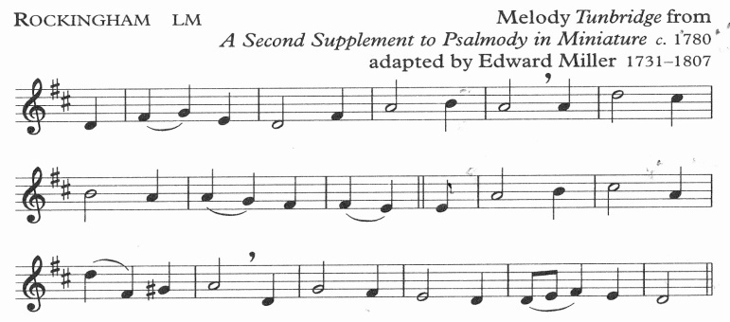

When I survey the wondrous cross

on which the prince of glory died,

my richest gain I count but loss,

and pour contempt on all my pride.

Ninth Station

## JESUS FALLS A THIRD TIME

Leader: We adore you, O Christ, and we bless you

**All: For by your cross, you have redeemed and saved us.**

Voice 1 On this fall he seems to fall farther into the ground.

It makes us wonder how we can stand by and watch,

as someone else is victimised.

It happens on streets often when people are mugged,

or in families when others know there is abuse,

or in a school where bullying by teachers or pupils is ignored;

or gossip spreads lies and we can't find the way to stop it.

When good people can do little or nothing,

evil flourishes and people fall by the wayside.

Or people fall and need help to get up,

and its more difficult the third time:

the boy or girl on the third attempt to get off drugs,

the woman or man trying to get free of alcohol,

the students who fail to study year after year.

Life can make us fragile

and the fall on the way

may be the push we got when we were

bullied or abused or slandered years ago.

We fall and rise on our own way of the cross,

and on his way up he raises us up.

**Prayers**

*Voice 2 Lord, you have been raised by the power of the Spirit,*

*you are the Saviour of the world.*

*Raise us up in courage when we fall.*

*Lord in your mercy,*

All: hear our prayer.

Forbid it, Lord, that I should boast

save in the cross of Christ my God;

all the vain things that charm me most,

I sacrifice them to his blood.

Tenth Station

## JESUS IS STRIPPED OF HIS CLOTHES

Leader: We adore you, O Christ, and we bless you

**All: For by your cross, you have redeemed and saved us.**

Voice 1 There seems to be horror on the faces of those who watch.

as the indignity of a stripping is carried out.

There's the physical pain of clothes being torn

and the other pain of being naked in public.

We think of many who share the same fate:

men and women strip-searched,

people who have been abused and raped,

people whose bodies have been exploited

in violence, pornography, medical science.

The soldiers needed to steel their feelings,

as we can dull our response to the pain of others.

Others watched:

maybe the friend who made the clothes in love,

the mother who bathed the body as a baby,

the friends who hugged the face of Jesus.

Did he remember these as he suffered at this station?

Memories of tenderness and comfort from others

get us through moments of indignity and pain;

memories of faith with God enliven us

in moments when we wonder if God is absent.

## Prayers

*Voice 2 Lord your dignity was stripped by the violence of others;*

*we pray for all who suffer abuse of' any sort,*

*whose dignity is robbed by the greed of others,*

*Lord in your mercy,*

All: hear our prayer.

See from his head, his hands, his feet,

sorrow and love flow mingled down;

did e’er such love and sorrow meet,

or thorns compose so rich a crown!

Eleventh Station

## JESUS IS NAILED TO THE CROSS

Leader: We adore you, O Christ, and we bless you

**All: For by your cross, you have redeemed and saved us.**

Voice 1 So different from how we like to think of death;

we wonder was Jesus unconscious as they nailed him.

Hardly — pain would have wakened him from any sedation

as the nails were hammered through his flesh given for us.

We can say that Jesus is nailed to the cross today -

just think of how we would hear

the sound of the nails in human cries:

millions starving, undernourished, hungry;

men and women imprisoned for the cause of justice;

the people living at the side of the road

or sleeping rough in our cities,

the meaninglessness in life leading to addiction,

the lack of love leading to casual relationships

and many ways people are not happy or content.

When others suffer Jesus is still nailed to the cross.

Its good for us to wince at the pain of others' lives.

And we watch - again the observers watch;

as pain kept Jesus from unconsciousness,

may the pain of others keep us awake

to the urgent pain of God nailed to modern crosses.

## Prayers

*Voice 2 As you searched for the love and will of your father*

*in your worst times of pain, dear Lord,*

*let us know the presence of your Father in our pain.*

*Lord in your mercy,*

All: hear our prayer.

His dying crimson, like a robe,

spreads o’er his body on the tree:

then am I dead to all the globe,

and all the globe is dead to me.

**[Move TWO stations forward]**

Twelfth Station

## JESUS DIES ON THE CROSS

Leader: We adore you, O Christ, and we bless you

**All: For by your cross, you have redeemed and saved us.**

Voice 1 The faces are sad, grieving, desolate;

isn't that what death can do to us?

And more so when death is

inflicted by humans on another human?

Was Mary praying a line from her Magnificat,

'He casts the mighty from their thrones and raises the lowly'?

Or was John remembering words like

1 will raise you up on the last day'

And Jesus — he seems to find trust and faith in this hour:

faith that his Father would not abandon him,

faith that the thief— out of sight just now —

would find happiness that day;

faith that John and Mary would care for each other.

And the women — was their faith strengthened

by the love they felt from Mary and John?

Recall that this picture has for centuries

helped millions through the darkest hour;

we know now what Jesus knew at the end of it all:

that others were with him to the end.

and maybe he knew that others were at a distance,

and that God is close and promises life forever.

*.*

## Prayers

*Voice 2 Holy Mary mother of God,*

*be with us in the worst of times,*

*pray for us, sinners,*

*now and at the hour of our death.*

*Lord in your mercy,*

All: hear our prayer.

Were the whole realm of nature mine,

that were a present far too small;

love so amazing, so divine,

demands my soul, my life, my all.

Thirteenth Station

**JESUS' BODY IS TAKEN DOWN FROM THE CROSS**

Leader: We adore you, O Christ, and we bless you

**All: For by your cross, you have redeemed and saved us.**

Voice 1 It all seems more gentle now.

Carried by friends into the future;

the hands and heart of God

touching and consoling him,

in the hands and hearts of

a parent, a friend, a follower.

Is there ever a time when we are unconnected?

Even in death, we need others,

and while death is the most lonely moment —

or seems so —

it's often the time we're most surrounded by love.

Did he not know that he was cared for now?

And maybe he knew all along the way

that these people cared but couldn't reach him.

As they took him down gently,

they tell us to take others down gently,

at bad times of life and love and illness.

People live on many crosses -

illness, loss, rejection, oppression

and we need those who want to take them down,

consolers and helpers at all sorts of bad times,

and lay them where life will be fuller and kinder.

## Prayers

*Voice 2 When pain and suffering is over, Lord and Saviour,*

*make us truly grateful*

*for all who have stood by us in bad times.*

*Lord in your mercy,*

All: hear our prayer.

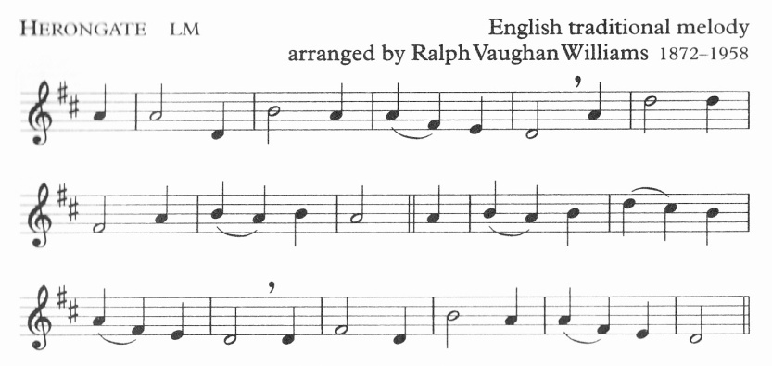

It is a thing most wonderful,

almost too wonderful to be,

that God’s own Son should come from heaven,

and die to save a child like me.

Fourteenth Station

## THE BODY OF JESUS IS LAID IN THE TOMB

Leader: We adore you, O Christ, and we bless you

**All: For by your cross, you have redeemed and saved us.**

Voice 1 There's care and love among them all

as they look on the one who has been sacrificed.

A mother’s love lasting through the falls and the violence,

and the followers who can't understand it all,

but are willing to give their hands and hearts to help.

Love doesn't always try to understand,

love can get into action before knowing why

and only in the doing is the knowing.

Often only love can reason why.

In getting involved, they got to know God.

For it was God they were holding:

the creator of the universe had become the servant,

and the servant had loved to the end.

Never again will the word 'tomb' mean the same,

for now because of Jesus the tomb

is the home of resurrection and life,

as every grave and urn promise new life.

The body is dead; the spirit is alive.

Love has conquered all

and in love faith and hope can still exist.

**Prayers**

*Voice 2 Give us patience Lard to know that*

*joy and life follow suffering and death;*

*and the peace of knowing*

*that your love will never fail us.*

*Lord in your mercy,*

All: hear our prayer.

*We return to the Lady Chapel singing:*

It is most wonderful to know

his love for me so free and sure;

but ‘tis more wonderful to see

my love for him so faint and poor.

And yet I want to love thee, Lord;

O light the flame within my heart,

and I will love thee more and more,

until I see thee as thou art.

## CONCLUSION *(please kneel)*

We leave the story of Jesus here knowing, however, that we are omitting the most important part of it, namely, the resurrection. Good came from this evil, joy from this pain, victory from this defeat, glory from this shame, life from this death.

Leader: Through the cross you brought joy into the world

**All: We worship you Lord, we venerate your cross, we praise your resurrection.**

Let us pray

Thank you, Lord, for sharing our struggles, our pain, our fear of death, and even death itself. Be with us in our sufferings. May we who have followed your painful Journey to Calvary, witness to you by lives of prayer, love, and service, and so come to share in your Easter victory. We ask this through you, who live and reign with the Father and the Holy Spirit, one God for ever and ever. Amen

Leader: Christ give us grace to grow in holiness, to deny ourselves, take up our cross, and follow him; and the blessing of God almighty, the Father, the Son and the Holy Spirit, be among us and remain with us always. **Amen**

*We remain kneeling for the final hymn [tune: Rockingham, page 12]*

When I survey the wondrous cross

on which the prince of glory died,

my richest gain I count but loss

and pour contempt on all my pride,

Were the whole realm of nature mine,

that were an offering far too small;

love so amazing, so divine,

demands my soul, my life, my all.